CREATING HEALTHY COMMUNITIES
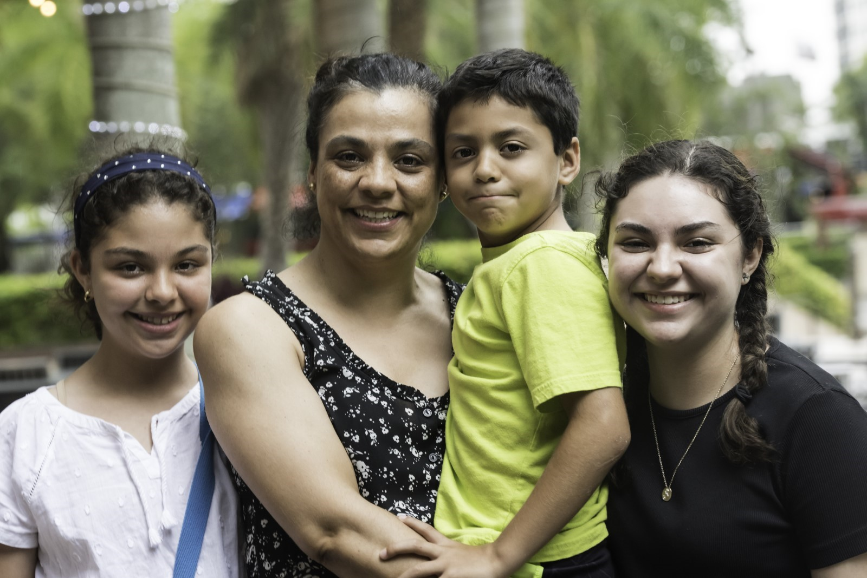
When you give to United Way, you help to create pathways for accessible healthy living.
United Way helps provide families with basic needs. Because of United Way’s support, a family was provided with nutritious food while navigating difficult times. A single mother, Jolene*, and her three children utilize their neighborhood’s popup pantry every month to receive healthy, fresh food that they normally would not be able to afford. Jolene says that the cost savings from the additional nutrition support allowed them to afford their utilities and rent on a new, safe, reliable apartment.
*Name has been changed to protect identity
With your support, individuals and families have access to healthcare and improve their health. Families and individuals have their basic needs met, safe places to live, and social and emotional connections to positively impact their quality of life.
Programs and work performed within this impact area aims to address gaps in access, opportunities, quality, and resources related to helping to meet residents’ basic needs, including food distributions, healthcare access, prenatal and maternal support, legal aid, social services, and more.
Strategies that aid the effectiveness of this impact area include:
- Increase access to physical, mental, dental, and social services
- Enhance physical environments to support individual and community well-being (e.g., affordable housing, community gardens, walking paths)
- Address gaps and disparities in healthcare access and outcomes (e.g., community health workers, preventative health screenings)
Help create possibilities for all individuals today.

