HAVE YOU MET ALICE?
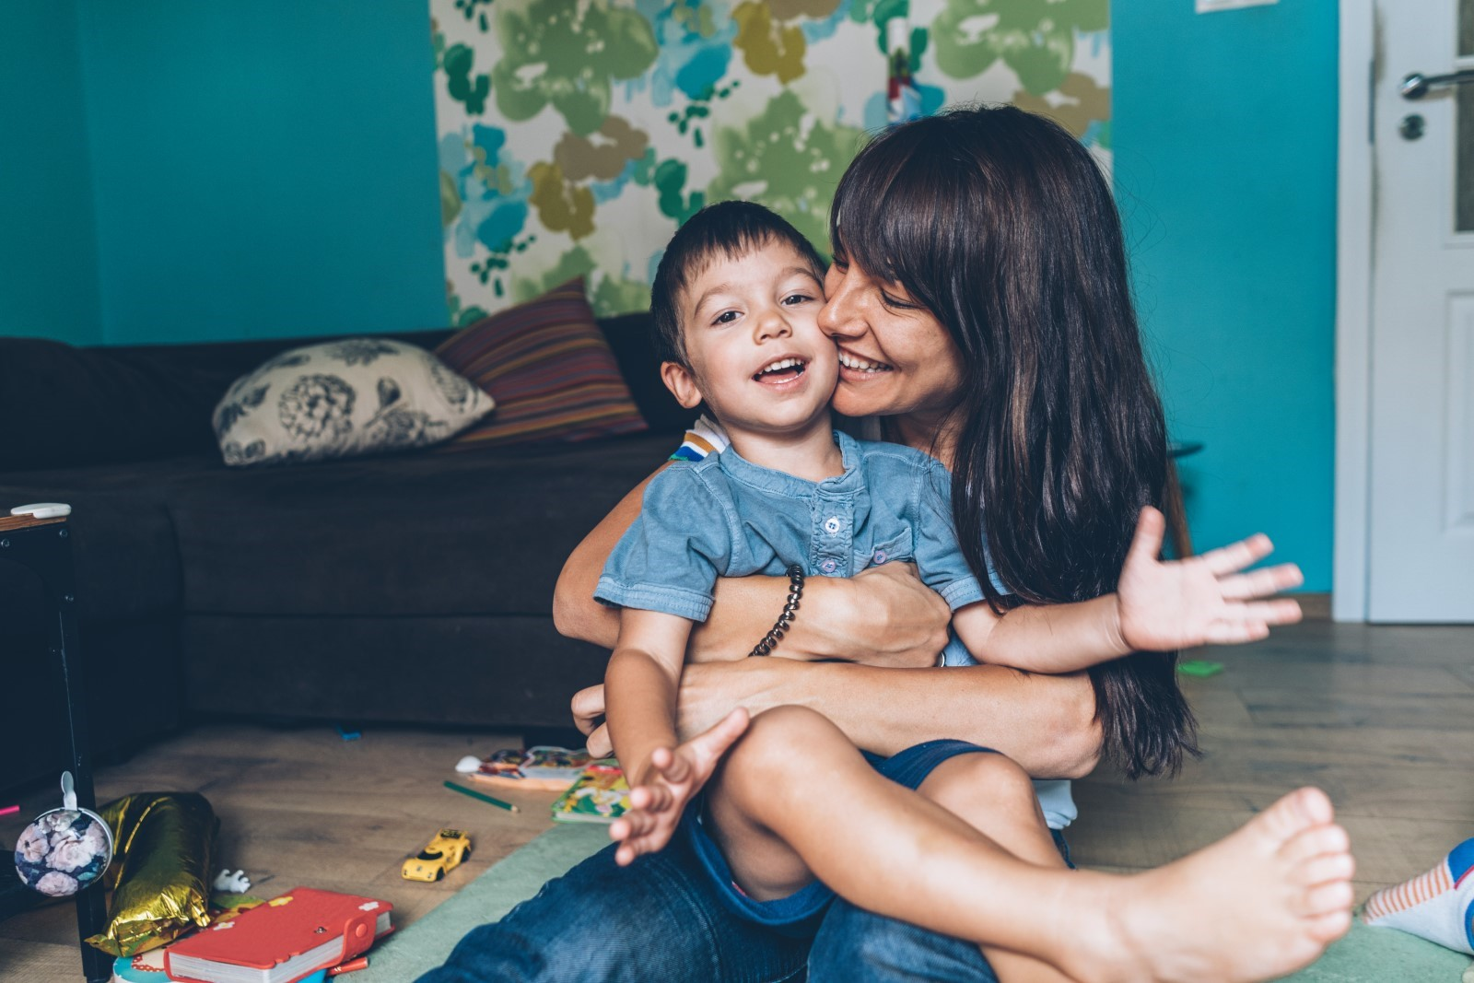
We all know ALICE – they may be a friend, relative, or coworker. All communities—regardless of race or ethnicity, social class, gender identity, religious or faith-based identity, (dis)abilities, or any other identity marker—within our six-county region are our priority. There is heightened attention to ALICE. ALICE is not one person, they stand for Asset Limited, Income Constrained, Employed, and represent nearly 120,000 families in the region who live above the Federal Poverty Level but below the cost of living.
The ALICE research investigates, on a local level, both household incomes and costs, exposing the disparity between low-paying jobs and resources necessary to survive financially, county by county.
As of 2021, 37% of households in the Greater Rochester and Finger Lakes region are struggling to afford the basics, which includes 55,856 households in poverty as well as another 116,305 families defined as ALICE.
Often overlooked and undercounted by traditional poverty measures, ALICE can be anyone—those with low wages, little or no savings, and one emergency away from poverty.
United Way convenes, advocates, and innovates throughout the communities it serves and drives attention to issues faced by ALICE households, and shapes solutions that promote financial stability. Learn more at unitedforalice.org and give to United Way today to support this important work.

